Home

Discover

Library

Reports

Groups

Marketplace
JavaScript Basics
Basic JavaScript questions about variables, conditionals, loops and functions. while(kahoot === running) { var student = "happy"; }
  - k plays • 19.7k players

A public kahoot

Questions (35)

1 - Quiz
What will log to the console?

8 


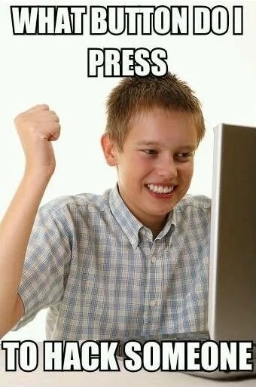
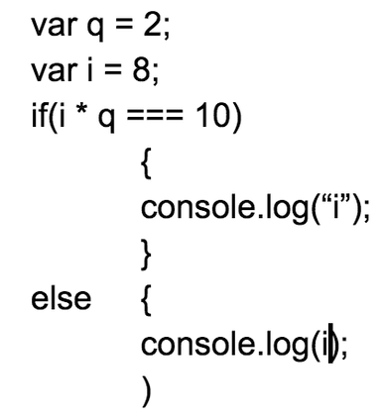







i

2 

False

    - - Quiz
What is the name of this function? var ptBreak = function(swellSize)
30 sec

var

ptBreak

function

swellSize

    - - Quiz
What command is used to ask the user a question in a pop up window?

alert

30 sec

confirm

prompt

function

- - Quiz
What happens when you concatenate ("this" + "that") ?
30 sec

thisthat

tt

this

that

- - Quiz
What happens when you concatenate var this = "GROWTH"; with var that = "MINDSET"; (this + that)

thisthat

30 sec






GROWTHMINDSET

GROWTH MINDSET

this that

- - Quiz
Find the Camel Case!
30 sec

camelcase

CamelCase

Camelcase

camelCase

- - Quiz
How long will the loop run? for(var i = 10; i < 10; i++)
30 sec

10

1

0

9

- - Quiz
What does not belong? for(var i = 0; i < 0; i++);
30 sec

=

var


<

;

- - Quiz
What is mom? var mom = "Very Nice!";
30 sec

Nice

Very

Very Nice

Nice Very

- - Quiz
Variables are the part of the program that...
30 sec

Repeats

Remembers

Chooses

Varies

- - Quiz
Conditionals are the part of the program that...
30 sec

Repeats

Remembers

Chooses

Varies

- - Quiz
Loops are the part of the program that...
30 sec

Repeats

Remembers

Chooses

Varies

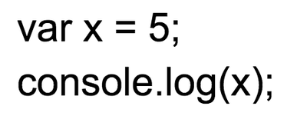

13 - Quiz
What will log to the console?

5

x

1

Function
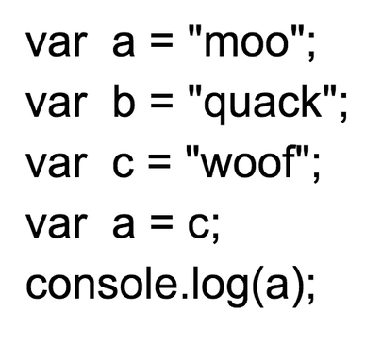

14 - Quiz
What will log to the console?

c

woof

quack

moo

15 - Quiz
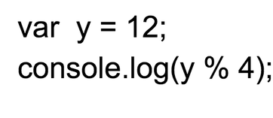

What will log to the console?

0

1

2

3

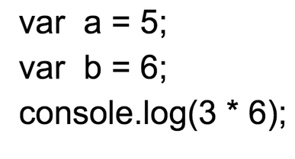

16 - Quiz
What will log to the console?


30

6

5

18
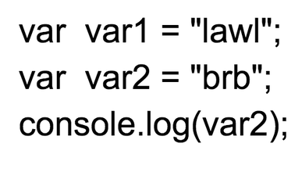

17 - Quiz
What will log to the console?

var

lawl

brb

var2

18 - Quiz
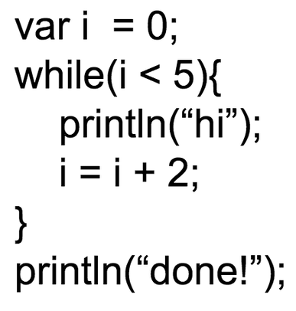

How many times will "hi" be printed?

2


3

4

5

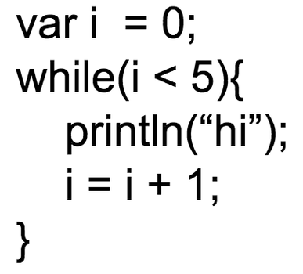

19 - Quiz
How many times will "hi" be printed?

2


3


4

5
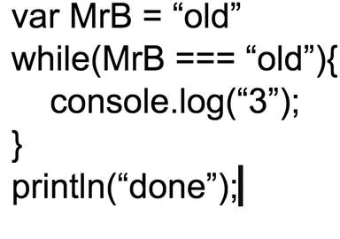

20 - Quiz
How many times will "done" print?

1

2

3

never

- - Quiz
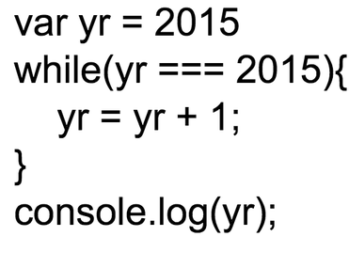

What will be logged to the console?

2015

2016

2017

2018

- - Quiz
What is the parameter? var apples = function(amount)
30 sec

var

apples

function

amount

- - Quiz
Where is your head? var brain = "In your iPad!";
30 sec

on my shoulders

In your iPad

function!?

brain

- - Quiz
Pick the for loop that runs 3 times...
30 sec

for(var i = 3; i < 10; i++)

for(var i = 3; i < 8; i++)

for(var i = 3; i < 6; i++)

for(var i = 3; i < 3; i++)
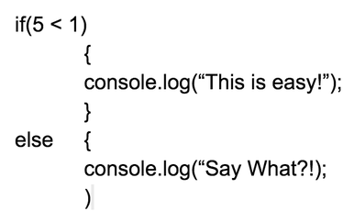

25 - Quiz
What will log to the console?

This is easy

Say What?!
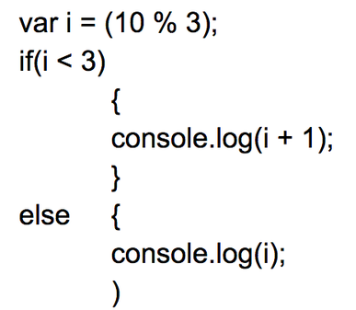

26 - Quiz
What will be logged to the console?

1

2

3

4
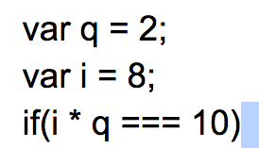

27 - Quiz
True or False?

True

False

28 - Quiz
What is the variable name? var tableSetting = "complete";
30 sec

complete

tableSetting

var

=
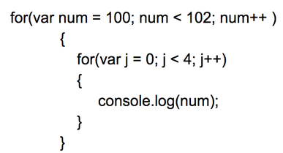

29 - Quiz
What will the loop log to the console?

100 101

100 100 100 100

100 100 100 100101 101 101 101

101 101 101 101
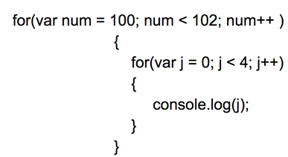

30 - Quiz
What will the loop log to the console?

100 100 101 101

0123

0 1 2 3 0 1 2 3

j

- - Quiz
True or False? if(500 > 499)
30 sec

true

FALSE!!!

- - Quiz
TRUE or FALSE????? if(5 + 43 <= 48)
30 sec

TRUE!!!

false

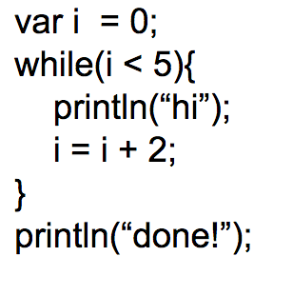

33 - Quiz
How many times will "hi" print?

none

5


2

3
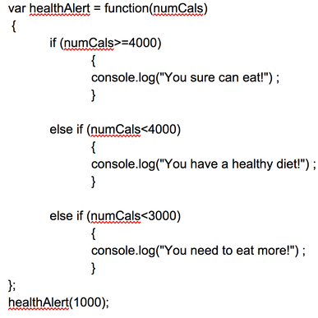

34 - Quiz
What is the name of the function?

numCals


healthAlert

var

function

35 - Quiz
Are Ya Getting This Stuff?!!!!
30 sec

YES

NO

WHO AM I?

I RULE

Resource credits

